Design document



Fire Safety e-Learning Course
Version | Date | Initials | Notes
0.01 |  |  | Initial draft
0.02 |  |  | Internal review
0.1 |  |  | Amends ready for client review
0.2 |  |  | comments
1.0 |  |  | Signed off with comments

C
ontents

1 Intro to this document 3
2 Requirements 4
2.1 Background 4
2.2 Audience 5
2.3 Programme aims 6
2.4 Learning objectives 6
3 Scope and structure 7
3.1 Micro-learning 7
3.2 Course sections 7
3.3 Course pages 8
3.4 Resources 9
3.5 Resource activity types 9
4 Content map 10
5 Artwork and Interactions 11
6 Functionality 14
6.1 Tone of voice 14
6.2 Audio/video 14
6.3 Hosting 14
6.4 Tracking 14
6.5 Locking 14
6.6 Translation and localisation 14
6.7 Maintenance 15
6.8 Accessibility 15
7 Appendix 16
7.1 Get started 16
7.3 Introduction 17
7.5 Using the fire extinguisher 18
7.6 Evacuation Procedures 19
7.7 Useful resources 20
8 Schedule/Process – (high level) 21

Intro to this document
This document describes the design methodology for the Fire Safety course
It includes a high-level scope that describes in detail the intended approach to the Fire Safety online course. The recommendations are based on:
- Experience of the current learning being given
- Initial meeting
Providing feedback
Please provide feedback using Microsoft Word’s track changes and commenting features. If you are collating feedback from more than one reviewer, please compile these into a single version of the document so that we have a definitive record of your feedback.
When we have received this feedback, we will action your amends and then return the document to you for sign off.
Terminology
The following terminology being used:
- Programme – the overall 120 minutes of training
- Course section – the proposal is that the content be broken down into six sections that cover two work groups- new hires and current employees
- Course page – a term that refers to the menu page used for each section
- Resources – the learning is split into small chunks. These take the form of Captivate pages, PDFs and present the learning through tutorials, resources, activities, quizzes, etc.
These are described in more detail in the Scope and structure section of this document.

Requirements
The requirements for this programme.

Background
Nationwide Building Society is looking to create a fresh approach to learning fire safety.
The e-learning will be deployed via the Learning Management System, Learning Zone, so that key Management Information can be captured and reported on.

The module, Fire Safety, will be delivered to both the Branch Network and Admin Centres.

Core topics include:

• Spotting hazards
• How to use a fire extinguisher
• Evacuation process

Employees new to the role will be encouraged to undertake the learning in one sitting, whereas employees in role will be prompted to visit hot topics via a predetermined communication programme. This means the design needs to be modular in nature.

It also needs to include specific user journeys for the target audience with relevant and specific content delivered based on the path selected. This module should rely on interactions, videos and animations to draw out the key learning points.

The e-learning should be an exemplary learning programme as it will have very wide reach within Nationwide. It needs to appeal to a broad audience, work for both new and experienced staff at all levels, and be easily maintained for future updates.

It should fully reflect the strong Nationwide brand and need to be delivered to the Nationwide’s technical specifications and design standards. Learning solutions can be pushed out to learners via our Learning Management System (Learning Zone) and therefore can be considered as part of the learning solution.

Employees will access the learning from their desktops and won’t be able to view from home PCs.

This solution must be built, approved and available to learners in six weeks’ time.

Audience
There are approximately 700+ branches as well as the HQ’s in Swindon and four admin centres spread across the UK. There are approximately 18,000 employees. This means that there needs to be a well-coordinated marketing and rollout plan to ensure that everyone knows about the courses and that this course is implemented smoothly and on time. With approximately 18,000 learners this also means a diverse population. Special attention needs to be placed on the tone and technicality of the script within the course ensuring that it is in plain and simple UK English.
Learners are diverse, and each have their own learning style preferences. The learners experience ranges from having no prior experience with fire safety to being well versed to current fire safety practises within the Nationwide organisation. The learners experience of using e-learning may also range from no experience to well versed in using technology, therefore there will be specific learning journeys considering experience levels with fire safety and technology.
The learners will be divided into two groups- new hires and current employees. Therefore, the learning will be tailored to these two groups and have specific learning journeys. They will only access the learning from a laptop device within the workplace.

Programme aims
These are based on the aim to help participants to:
- identify problems – the main fire safety issues within Nationwide facilities
- involve employees – by making them more aware of fire safety issues and the need for action
- improve fire safety – by proposing plans for controlling hazards and improving the working environment
- develop skills – to be able to effectively:
  - use the knowledge to spot hazards and fix them,
  - use fire extinguishers in the event of a fire
  - evacuate and help others evacuate in case of a fire.

Learning objectives
Learning objectives have been identified for each of the resources in the scope:
By the end of this course, you will:
- Understand how to ensure your business or premises complies with fire safety regulations.
- Understand your duties in eliminating or reducing the risk of fire in the workplace.
- Be aware of the components and causes of fire.
- Be able to undertake a fire risk assessment.
- Have a clear understanding of fire safety procedures and the steps to be taken in the event of a fire.
- Be able to distinguish between different types of fire extinguisher and understand their uses and constraints.

Scope and structure
The following section discusses ideas for the programme’s overall structure and methodology.

Micro-learning
The programme will take an approach that roughly follows ‘micro-learning’ principles. This fits well for learners who are current employees and might be fitting training in between other tasks. The main principles are:
- Short bursts of learning – wherever possible, tutorials and activities are chunked into pieces of approximately 5 minutes. If videos are featured, we keep these under three minutes.
- Self-paced – current employees can explore the content and select the learning in an order that’s most convenient for them, however, new employees will take the course in one sitting.
- Easily navigable – use of icons and clear categorisation to help the learner orient themselves in the programme
- Clear progress – the Learning Zone LMS course pages will show the learner progress
- Designed for multi-session learning – the design of the programme will provide clear starting points and making sure each chunk of learning is self-contained
- Granular – learners can get to specific content quickly and easily, making the programme double as a great toolkit or revision aid

Course sections
The intention is to break the content down into meaningful sections, based on the learning objectives, navigating the course ‘Getting started’ section, an ‘Introduction section’ including a video given by the lead Nationwide Chief Safety Officer describing the importance of fire safety, and a ‘Resources section’.
A resources section will also be given as essential way of pulling together all the documentation included in the course such as examples, checklists, and reference material needed to effectively implement fire safety within the workplace.
The table below itemises the proposed sections and approximate durations (loosely based on an average of each resource taking the learner 5 minutes to complete).

 | Section | Number of resources | Learner time (hrs)
1 | Getting started | 1 | 5 minutes
2 | Pre-assessment current employees | 3 | 30 minutes
3 | Introduction | 1 | 5 minutes-includes a 3-minute video
4 | Spotting hazards | 4 | 35 minutes
5 | How to use a fire extinguisher | 4 | 35 minutes
6 | Evacuation process | 4 | 35 minutes
7 | Useful resources | 5 to 10 pdfs estimated | 10 minutes
For those that take the pre-assessment and pass 35 minutes
Tutorial without pre-assessment, total: approximately 2 hours on screen
Plus 30 minutes to carrying out activities in the workplace

These sections will appear as a menu in the LMS.

Course pages
Each piece of learning content is launched from course pages on the LMS. This brings the content together into a cohesive journey.
There will be a course page created for each of the six sections.
The items in each section appear as a series of tiles.

Resources
The resources that are launched from the course page take the form of Captivate activities. An art direction for the fire safety programme will be produced.

Resource activity types
In referring to a resource activity type, it means a type of learning that is launched from the within a particular resource on the LMS course page. The following table contains suggestions and comments for the range of resource types that will be used.
Type | Comments
Video | In video format embedded in the Captivate pages:  - screen capture video to create a ‘how to navigate’ guide  - Intro by Chief Safety Officer
Explainer animations | Simple animations with audio narration, in video format embedded in Captivate page, to help explain a demonstration
Presentations | A variety of different styles to present information in the Captivate pages:  - Case study  - Step-by-step guide  - Tips (numbered or under specific headlines)  - Lists (of information/tips/links)  - Checklist (e.g. to gauge learner readiness)
More information (button) | A mechanism for revealing short chunks of more detailed information on an Adapt page.
Infographics | Interactive graphics presenting information in a visual way.
Quiz | Often forming part of a presentation – the learner answers a series of questions to gain insight about themselves, reflect on what they know or test their assumptions and receive feedback to align their understanding:  - Diagnostic  - Reflective/test assumptions  - Skills audit
Call to action /reflection point | Standard components found at the end of each resource:  - Prompt to carry out a workplace activity (with accompanying worksheet)  - Reflection point to go over what was learned
PDFs | Some standalone PDFs as reference material in the ‘Useful resources’ section

Content map
The following pages scope out the project and describe how the content will be proposed for the resources.
This may change during the scoping and scripting stage as we discuss the content in more detail, but gives a general direction of the how the programme will look and feel to the learner.
Source material will be invaluable in terms of supplying the detail needed to cover, in addition to further conversations with your SMEs.
Here is a high-level breakdown of the sections and sub-sections. These are then explored in more detail in the Appendix.
Section | Resource
Getting started | Finding your way around
Getting started | How to get the most from this course
Pre-assessment | Current workers can watch scenarios/ and then random question selected quizzes
Introduction | The Nationwide Chief Safety Officer
Spotting hazards | Importance and impact
Spotting hazards | Steps to effectively spot different hazards
Spotting hazards | Demonstration of effectively spotting hazards
Spotting hazards | Take part in this scenario
Spotting hazards | An action plan
How to use a fire extinguisher | Importance and impact
How to use a fire extinguisher | Steps for various types of fires
How to use a fire extinguisher | Demonstration on how to effectively use
How to use a fire extinguisher | Take part in this scenario
How to use a fire extinguisher | An action plan
Evacuation process | Importance and impact
Evacuation process | The process steps
Evacuation process | Demonstration of an evacuation process
Evacuation process | Take part in this scenario
Evacuation process | An action plan
Useful resources | ~PDF’s for useful resources and action plans

Artwork and Interactions
We will follow the Nationwide Building Society branding guidelines. The artwork should be consistent throughout and the images and characters should be as realistic as possible.
The AD will be based on this look and this an example of the types of interactions/screen types.

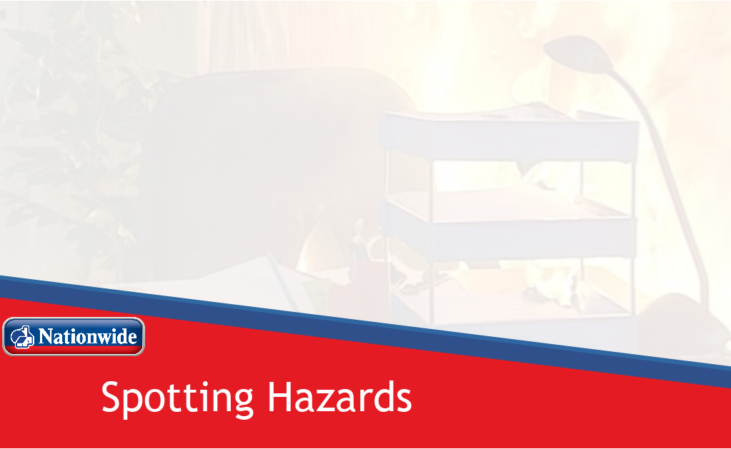
Each tutorial section will have a Title page and learning objectives page

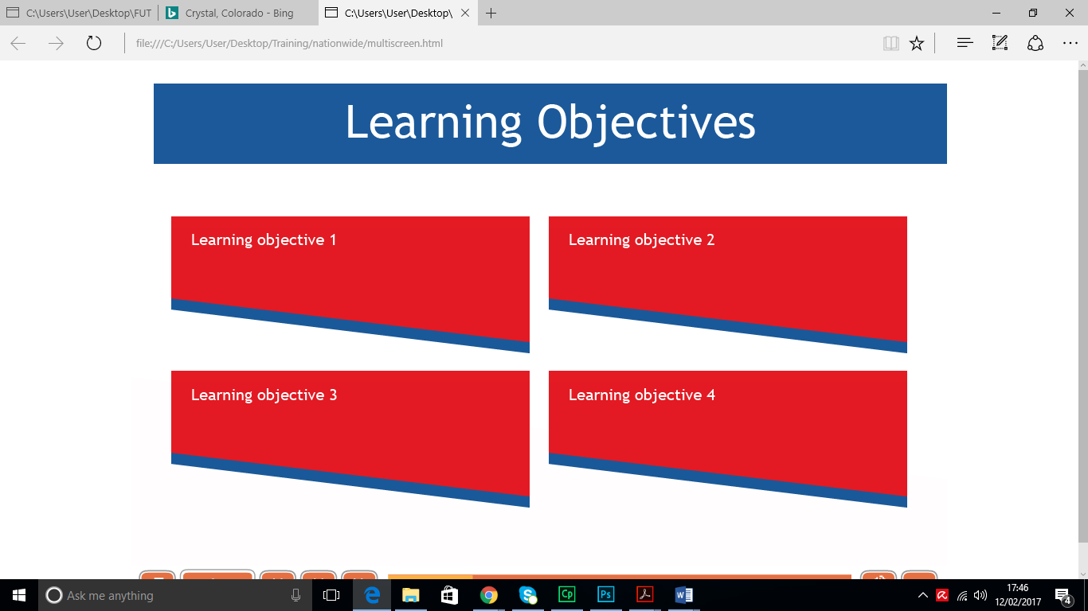

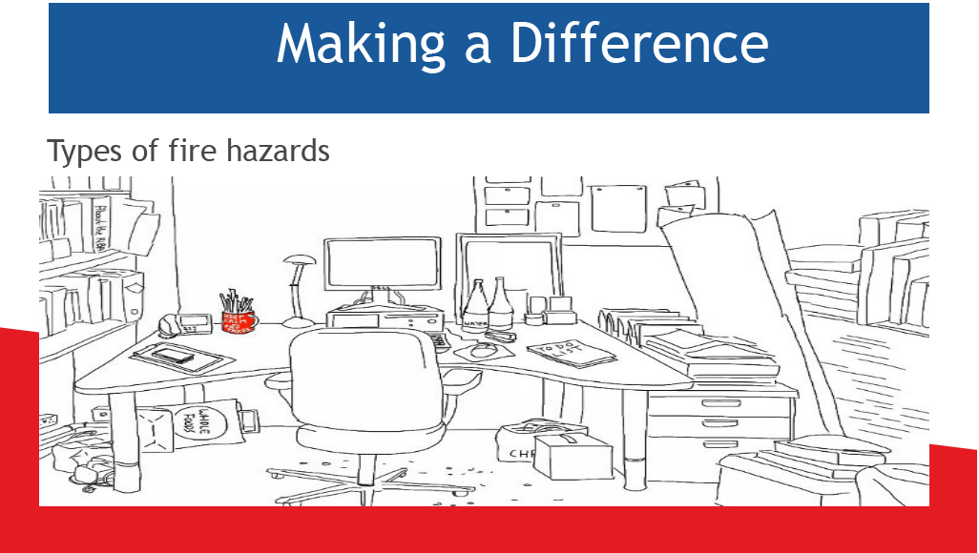
The 5-minute tutorials will have a variety of interactions to present the content to the learner such as hot spots, click and reveal pictures, drag and drop and sliders.

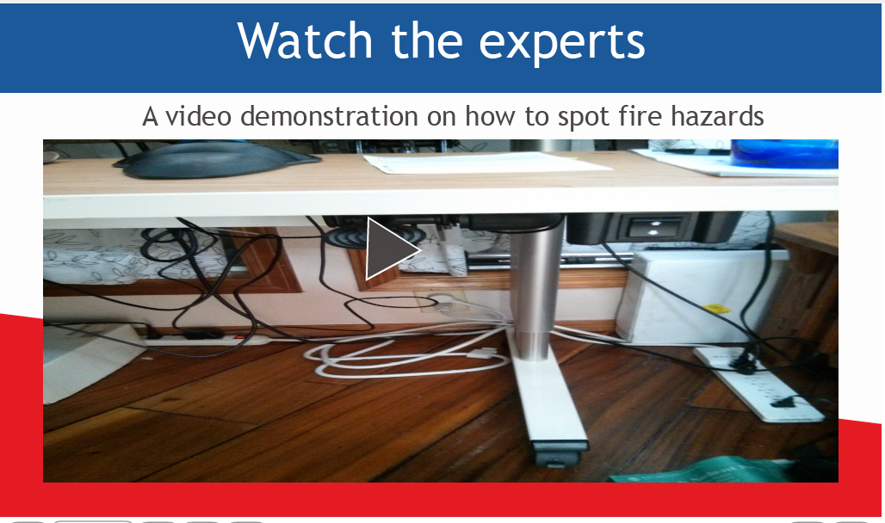
Each Section will have a demonstration video of an expert performing correct procedures.

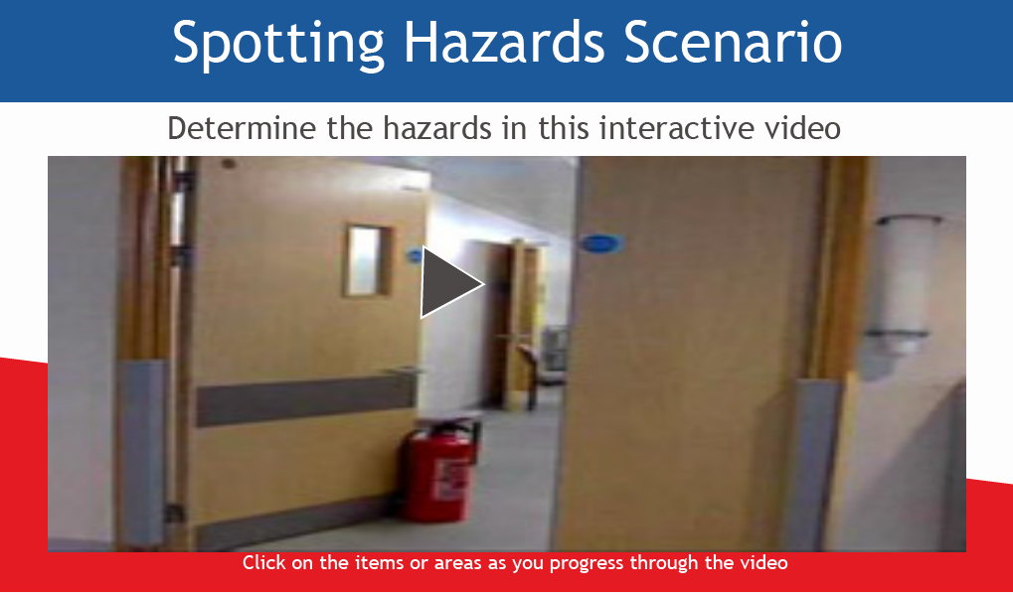

Each Section will have an interactive branching video/ quiz
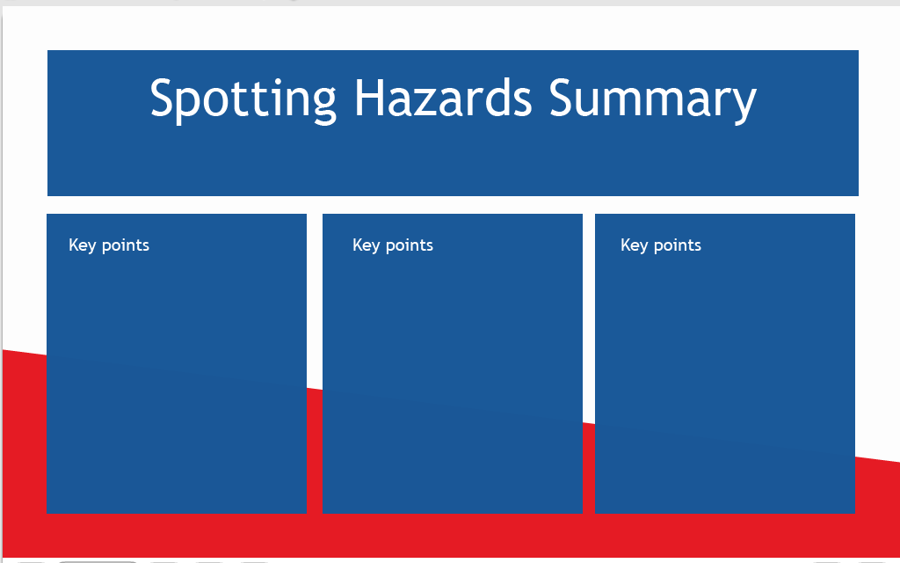

Each Section will have a summary of key points

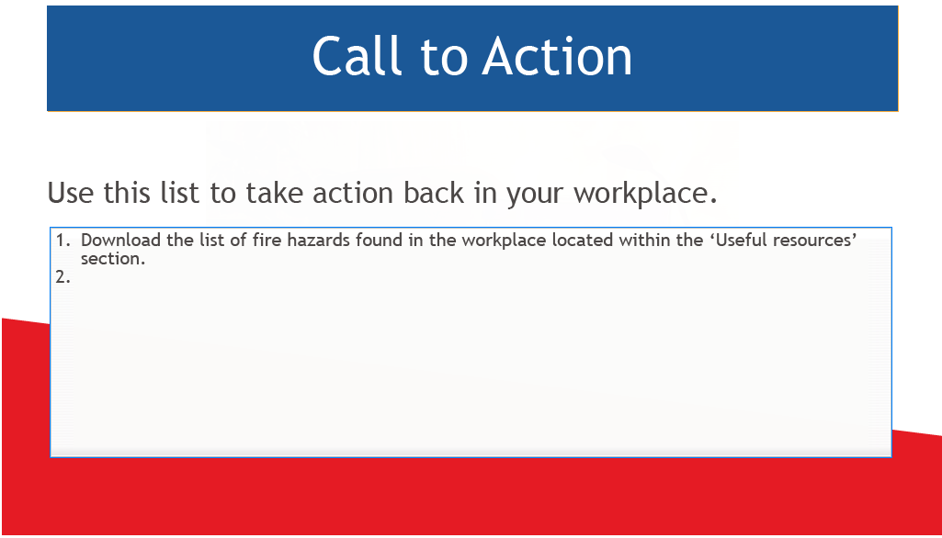

Each Section will have a ‘Call to Action’ that provides an activity for the learner to conduct in their workplace.

Functionality
The details of exactly how the programme will function.

Tone of voice
We will follow the tone of voice for plain English guidelines. We’ll work within style guidelines to make the content accessible to learners with low literacy levels.

Audio/video
The following videos would be used:
- 1-Video/screen capture – welcoming learners to the course, explaining how to navigate the menus and the pages and describing typical functionality

- 1- Video – Nationwide Chief Safety Officer
- talking about Fire Safety and its importance
- sharing examples of how a good Fire Safety programme makes a difference

- 3-Videos – Demonstrations
- three demonstrations – spotting hazards, using the fire extinguisher, and evacuation procedures. These could possibly be animated.

- 3- Videos – Interactive
- Three interactive branching videos - spotting hazards, using the fire extinguisher, and evacuation procedures.

Hosting
The programme will be hosted on Nationwide’s Learning Zone platform.

Tracking
Content will be tracked using SCORM 2004. Progress through content will not be locked and all content will count towards programme completion.

Locking
None of the content will be locked.

Translation and localisation
The programme will be UK English only.

Maintenance
We will follow Nationwide guidance on how to edit the Captivate source files to enable text and imagery changes.

Accessibility
Building of all components may ensure that we meet accessibility requirements i.e. ‘AA’ level of the Web Content Accessibility Guidelines.

Appendix

Get started
This section will help employees to get the most out of this programme.
Page title / resource name | Learning objectives | Proposed interaction type(s) | Source material
1. Finding your way around | - Describe how to navigate the course | - Video/screen capture – welcoming learners to the course, explaining how to navigate the menus and the pages and describing typical functionality | n/a

7.2 Pre-assessment for current employees
This section is for current employees to demonstrate they already have proficiency in the tasks.
Page title / resource name | Learning objectives | Proposed interaction type(s) | Source material
1. Fire safety pre-assessment | - Demonstrate knowledge of fire safety | - Quiz- This quiz will be for current employees who are confident that the they have the knowledge necessary to carry out fire safety. The quiz will be a set of three scenarios covering spotting hazards, operating fire extinguishers, and evacuation procedures. The learner will be given questions on situations and asked what they would do. | n/a

7.3 Introduction
This section will help employees to:
> understand the importance of taking this programme.
Page title / resource name | Learning objectives | Proposed interaction type(s) | Source material
1. Importance of the Fire Safety Programme | - Recognise the importance of the fire safety | - Video – expert set the scene in an upbeat way and reinforce the importance  - Reflection point – how confident do you feel about conducting fire safety? | Nationwide Chief Safety Officer

7.4 Spotting Hazards
Page title / resource name | Learning objectives | Proposed interaction type(s) | Source material
1. Making a difference | - Identify the importance and impact you can make on fire safety | - Tutorial 5minutes- fire regulations, types of hazards (captivate interaction)  - Reflection point- summarise the main points and how they can use
2. Spotting hazards in your workplace | - Identify the steps involved in spotting hazards | - Tutorial 5-minute guide of steps – categorises and summarises the main steps in eliminating risks  - Reflection point – we’ll invite the learner to consider whether they think that steps will work within their workplace
3. Watch how to correctly spot hazards | - Identify the steps in spotting hazards | - Video- Video of an expert as they go through applying the steps.  - Call to action – focus on the steps and determine how to use it within your workplace
4. Spotting hazards scenario | - Use the steps to identify hazards in a scenario | - Tutorial 10-minute interactive video scenario quiz-with branching giving the learner specific feedback on their choices.
5. An action plan | - Use the steps in the workplace using the pdf in the resources. | - List – a reminder of the steps and summary of the points made  - Call to action – can you spot the hazards in your workplace? Use the pdf in ‘Useful resources’ section and apply it to your area. Turn in the pdf to your supervisor and go over any hazards that need to be fixed.

  - Using the fire extinguisher
Page title / resource name | Learning objectives | Proposed interaction type(s) | Source material
1. Making a difference | - Identify the types of fires and the types of extinguishers | - Tutorial 5minutes- fire types, types of extinguishers (captivate interaction)  - Reflection point- summarise the main points and how they can use
2. Steps for various types of fires | - Identify the steps involved in for various types of fires | - Tutorial 5-minute guide of steps – categorises and summarises the main steps for fire extinguisher use  - Reflection point – we’ll invite the learner to consider how the steps will work within their workplace
3. Watch how to correctly use the fire extinguisher | - Identify the steps in using the fire extinguisher | - Video- Video of an expert as they go through applying the steps.  - Call to action – focus on the steps and determine how to use it within your workplace
4. Extinguish the fire scenario | - Use the steps to extinguish several types of fires | - Tutorial 10-minute interactive video scenario quiz-with branching giving the learner specific feedback on their choices.
5. An action plan | - Use the steps in the workplace using the pdf in the resources. | - List – a reminder of the steps and summary of the points made  - Call to action – What extinguishers are in your workplace? Use the pdf in ‘Useful resources’ section and apply it to your workplace

Evacuation Procedures
This section will help
Page title / resource name | Learning objectives | Proposed interaction type(s) | Source material
1. Making a difference | - Identify the importance and impact you can make on fire safety evacuations | - Quiz – diagnostic style quiz to reflect on evacuation procedures and the difference it can make. Feedback summarises the main steps.  - Reflection point- summarise the main points and how it would be used in their workplace
2. Evacuation procedures in your workplace | - Identify the steps involved in evacuating | - Tutorial 5-minute guide of steps – categorises and summarises the main steps  - Reflection point – we’ll invite the learner to consider how to use the steps within their workplace
3. Watch how to correctly evacuate | - Identify the steps in evacuating | - Video- Video of an expert as they go through applying the steps.  - Call to action – focus on the steps and determine how to use it within your workplace
4. Evacuation procedures scenario | - Use the steps to identify procedures | - Tutorial 5-minute scenario with branching giving the learner specific feedback on their choices.
5. An action plan | - Use the steps in the workplace using the pdf in the resources. | - List – a reminder of the steps and summary of the points made  - Call to action – Do you know your evacuation plan for your workplace? Use the pdf in ‘Useful resources’ section and apply it to your area. Turn in the pdf to your supervisor and go over evacuation procedures that might need to be fixed.

Useful resources

Page title / resource name | Learning objectives | Proposed interaction type(s) | Source material
1. Pdf’s for information and action plans | - Use the procedures learnt in your own workplace | - Various activities and resources available

Schedule/Process – (high level)
TASK | PHASE | OWNER | WK1 |  |  |  |  |  |  | WK2 |  |  | WK3 |  |  |  |  | WK4 |  | WK5 |  |  |  |  |  | WK6
PROJECT PLANNING | Analysis
Content wrkshop |  | ID/SME
Design doc.
Project Kick-Off Meeting |  | All
Create Course Project Plan |  | ID
Review Course Project Plan |  | ID/SME/  sponsor
STORYBOARDING | Design
Storyboard 1st Draft |  | ID
Review Storyboard 1st Draft |  | SME/  sponsor
Storyboard 2nd Draft |  | ID
Review Storyboard 2nd Draft |  | SME/  sponsor
PROTOTYPE | Development
Prototype 1st Draft |  | Developer
Review Prototype 1st Draft |  | ID/SME/  developer
DEVELOPMENT
Course 1st Draft |  | Developer
Review Course 1st Draft |  | SME
Course 2nd Draft |  | Developer
Review Course 2nd Draft |  | SME
Course Final Draft |  | Developer
Approve Course Final Draft |  | SME
TESTING & QA | Implementation
Test Course |  | Developer
Make Final Course Edits |  | Developer
COURSE DELIVERY
Publish to LMS |  | LMS Admin
Communicate Course Availability |  | SME

